Follow-Up FSA Outreach Email

Subject Line: Still thinking about an FSA?
Preview Text: Now’s the perfect time to start planning for next year

Hello <EmployeeFirstName>,

I hope that you’re having a great day! I wanted to follow up regarding the recent Flexible Spending Account (FSA) email I sent you and to see if you had any questions about enrollment.

We feel so strongly about the benefits of this product that we hope you take advantage! FSAs offer personalized and flexible spending options that work together with your other benefits to help ensure you’re prepared for life’s unexpected moments.

From tax savings, convenience tools like the FSA Store, and some unique benefits like mental health coverage and COVID care, FSAs can be a life-changing addition to your current accounts.

Don’t forget… you can enjoy $35 off $150 at the FSA Store with coupon code: INSIDER
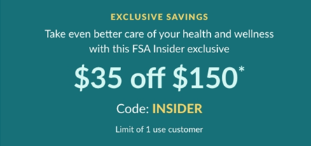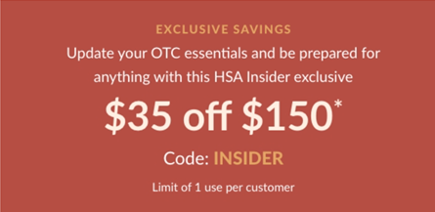

If you have any questions about FSAs or want to learn how to enroll, feel free to give me a call or reach out by email!

Thank you so much for your time and I look forward to connecting with you soon!

<YOUR CONTACT INFO HERE>

